LPE2504 CREATIVE WRITING SKILLS
SEMESTER 1 – 2025/2026
LECTURE NOTES 1 – WEEK 6

WEEK 6

METAPHOR & SIMILE


Discussion
Look at the following pictures and describe what idea or emotion that they can be compared to.

Picture | Comparison
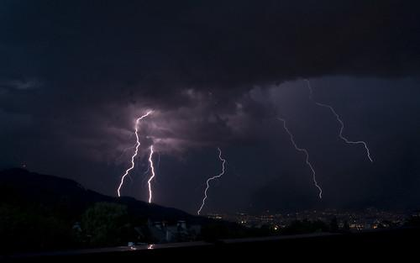  This Photo by Unknown Author is licensed under CC BY | e.g. Thunder can be compared to the emotion of anger.


This Photo by Unknown Author is licensed under CC BY
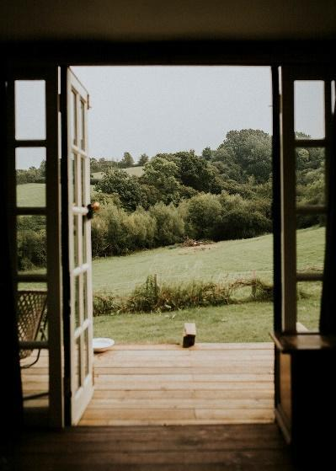

- From the activity above, can making comparison be a good way to clearly convey an idea or a message?

These indirect comparisons are similar to metaphors and similes as they both compare two different things but without using explicit comparison words.

From the activity, you are now aware that when you describe images without direct comparisons and also the implied comparisons. These comparisons related to the ideas of metaphors and similes in language.

Metaphor

Metaphor is the comparison between two unrelated elements that share some common characteristics.

Example: | “My brother is the black sheep of the family”
Explanation: | The phrase is a metaphor because he is not a sheep, nor is he black. However, we can use this comparison to describe an association of a black sheep with that person. A black sheep is an unusual animal, which typically stays away from the herd, and the person described as such shares similar characteristics.

Simile

Simile is common poetic device where the subject of the poem is described by comparing it to another object or subject, using 'as' or 'like'.

Example: | “John is as slow as a snail”  “John is walking slowly like a snail”
Explanation: | Snails are notorious for their slow pace, and here the slowness of John is compared to that of a snail. The use of “as” in the first example and “like” in the second example helps to draw the resemblance.

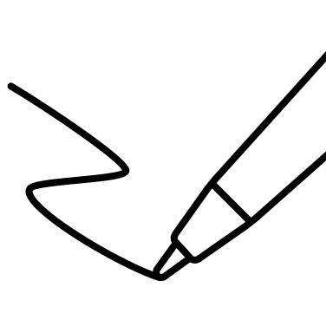
Activity 1: Meanings of Metaphor and Simile
Here are examples of metaphor and simile. Write the perceived meaning for each of the examples.

Metaphor | Explanation
My brother was boiling mad.
The assignment was a breeze.
Her voice is music to his ears.
The skies of his future began to darken
It is going to be clear skies from now on.

Simile | Explanation
The glow of the tube-light was as bright as sunshine.
The diplomat said the friendship of the two countries was as deep as an ocean.
At exam time, the high school student was as busy as a bee.
In winter, when it rained he climbed into bed, and felt as snug as a bug in a rug.

Activity 2: Identifying Metaphor and Simile
Read the poems below and underline and label the metaphors and similes in the poems.

Poem 1

My brother is a dragon.
My mom’s a teddy bear.
I am a shaggy sheepdog
With a ton of tangled hair.

Anonymous

Type of Literary Device: Metaphor / Simile

Poem 2

At night my brother snores so loud
it sounds just like a riot.
Even when he sleeps
my noisy brother isn’t quiet.

My Noisy Brother by Bruce Lansky

Type of Literary Device: Metaphor / Simile

Poem 3

Hope is the thing with feathers
That perches in the soul,
And sings the tune without the words
And never stops at all.

Hope is the Thing with Feathers by Emily Dickinson

Type of Literary Device: Metaphor / Simile

Poem 4

O my Luve's like a red, red rose
That’s newly sprung in June:
O my Luve's like the melodie
That’s sweetly play'd in tune.

A Red, Red Rose by Robert Burns

Type of Literary Device: Metaphor / Simile

Function of Metaphor and Simile
The following are some functions of metaphors and similes:
- To convey complex ideas or concepts in a more understandable and relatable manner. By associating the unfamiliar with the familiar, readers can grasp abstract ideas more easily.
- Appeals directly to the senses of listeners or readers, sharpening their imaginations to comprehend what is being said.
- Gives a life-like quality to the conversations, and to the characters of the fiction or poetry.

Adapted from “Metaphor” & “Simile” (n.d.). Literary Devices: Definition and Examples of Literary Terms at https://literarydevices.net/

Activity 3: Let’s Compare
- In pairs, write a two-liner with using metaphor and simile for each of the following themes.

Example:

- Life

Metaphor:
"Life is a rollercoaster, with its highs and lows."

Simile:
"Love is like a blooming flower, fragile yet beautiful."

- Conflict

- Nature

- Death

- Hope

- Loneliness

- Hope

- Your own theme

Activity 4: Let’s Write
- Choose one of the themes in Activity 3. Expand the theme by writing a four-line two-stanza poem using metaphor and simile. You may add other suitable literary devices that you have learnt previously.

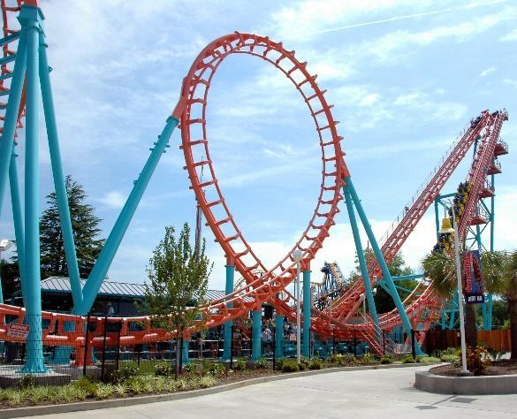

________________________________________________________________________________________________________________________________
________________________________________________________________________________________________________________________________
________________________________________________________________________________________________________________________________
________________________________________________________________________________________________________________________________________________________________________________________________


Summary
Metaphors and similes are literary devices used in writing to draw comparisons between two different things. Metaphors directly assert that one thing is another, while similes use "like" or "as" to compare two elements, both serving to enrich the imagery and create vivid mental pictures in writing.

Metaphors deepen the meaning of a text by implicitly suggesting a comparison, while similes explicitly compare two dissimilar things, making descriptions more accessible and enhancing the reader's understanding. Both devices play a vital role in engaging readers and evoking emotions by illustrating relationships between the familiar and the unfamiliar.

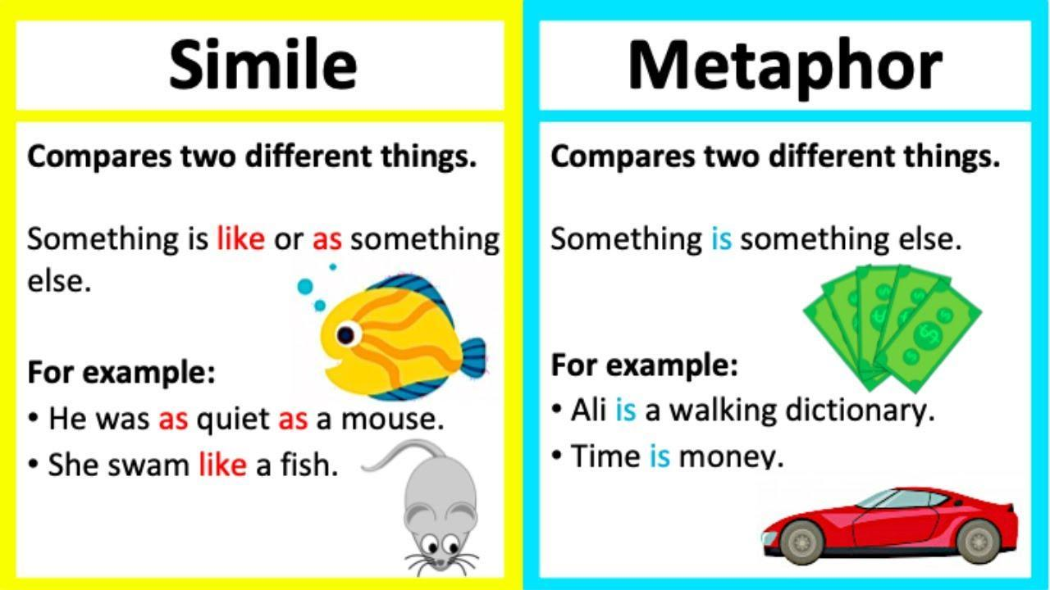

ASSONANCE

Discussion
Read the following poem / lyric and analyse it by answering the following questions.

Tyger Tyger, burning bright,
In the forests of the night;
What immortal hand or eye,
Could frame thy fearful symmetry?

In what distant deeps or skies.
Burnt the fire of thine eyes?
On what wings dare he aspire?
What the hand, dare seize the fire?

- Which part of the poem has the same vowel sound?

- What vowel sounds are repeated?

- From the repeated sounds, what images or emotions are projected?

Activity 1: Identifying Assonance: Vowel Harmony Hunt
Underline the assonance in the following poem and identify the emotion / imagery that is projected.

Hear the mellow wedding bells,
Golden bells!
What a world of happiness their harmony foretells!
Through the balmy air of night
How they ring out their delight!
From the molten-golden notes,
And all in tune,
What a liquid ditty floats
To the turtle-dove that listens, while she gloats
On the moon!
Oh, from out the sounding cells,
What a gush of euphony voluminously wells!
How it swells!
How it dwells
On the Future! how it tells
Of the rapture that impels
To the swinging and the ringing
Of the bells, bells, bells,
Of the bells, bells, bells, bells,
Bells, bells, bells—
To the rhyming and the chiming of the bells!
Hear the tolling of the bells—
Iron bells!
What a world of solemn thought their monody compels!
In the silence of the night,
How we shiver with affright
At the melancholy menace of their tone!
For every sound that floats
From the rust within their throats
Is a groan.
And the people—ah, the people—
They that dwell up in the steeple,
All alone,
And who tolling, tolling, tolling,
In that muffled monotone,
Feel a glory in so rolling
On the human heart a stone—

From the activity, you are now aware that the sounds are similar sounding, and this is the literary device of assonance. Assonance is the repetition of vowel sounds in two or more words which is sometimes called vowel rhyme.

Function of Assonance
The following are some functions of assonance:
- Assonance adds a melodious quality to the language, enhancing the rhythm and cadence within the text.
- It helps draw attention to specific words or phrases, emphasising the meaning or emotional impact of those words.
- Assonance can establish the mood or tone of the text, depending on the vowel sounds repeated, influencing how the audience feels while reading or hearing the text.

Adapted from “Assonance” (n.d.). Literary Devices: Definition and Examples of Literary Terms at https://literarydevices.net/

Activity 2: Let’s Write
In pairs, write a one stanza poem for each of the following vowel sounds.

  - /ɒ/ (oh)
________________________________________________________________
________________________________________________________________
________________________________________________________________
________________________________________________________________
  - /iː/ (e)
________________________________________________________________
________________________________________________________________
________________________________________________________________
________________________________________________________________

  - /eɪ/ (ei)
________________________________________________________________
________________________________________________________________
________________________________________________________________
________________________________________________________________

Summary
Assonance, a literary device found in poetry and prose, involves the repetition of vowel sounds within words placed in close proximity.
It adds a musical quality to language, enhancing the text's rhythm, tonal quality and auditory experience.
It also plays a crucial role in influencing the mood and tone of a piece of writing. It aids in establishing an atmosphere and can underscore the thematic elements of the work.
Through the strategic use of repeated vowel sounds, assonance helps to convey specific emotions, creating an experience that resonates with readers and emphasises the intended messages of the text.
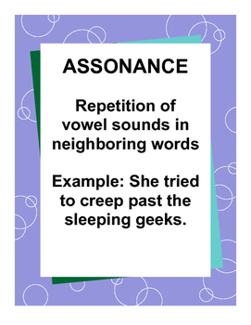

This Photo by Unknown Author is licensed under CC BY-SA

